NAME: _____________ | Probability
Stats | DATE: Tuesday, December 15, 2015

Review:
There are 16 people in this class, Im going to put 5 people in the front. How many different groups of 6 could I put in the front? | There are 16 people in this room. Three people will become teachers. How many different groups of 3 could it be?

Chandler is going to go to Oxford Casino and try his luck at Blackjack. The way he plays, he has a 45% chance of winning. If he plays 5 hands, find
P(all wins): | P(no wins):
P ( at least one win): | P(at least one loss):
Find the probability that he wins only once?

What is the chance that he wins the first 3 hands, then loses the next two?

How many different ways could he win 3 hands and lose 2 (in any order)?

So what is the chance that he wins 3 out of 5 hands?

Fill in the table:
Wins | 0 | 1 | 2 | 3 | 4 | 5
Probability

What is probability that he wins more than he loses?
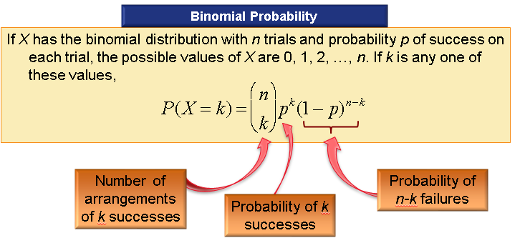

Example: The chance of a high school student in America going to college is 65%. If you randomly choose 10 kids, what is probability that 8 will go to college?

Example: The chance of a high school student in America going to college is 65%. If you randomly choose 10 kids, what is probability that at least 8 will go to college?

Using the online calculator:
1. find P(2 successes)
2. find P(10 successes)
3. In a history class, Ryan and Mary both take a multiple choice quiz.
There are 10 questions. Each question has four possible answers. What is
the probability that
- Ryan will pass the test if he guesses an answer to each question.

- Mary will pass the test if she studies so that she has a 75% chance of answering each question correctly.

4. Approximately 3% of the eggs in a store are cracked. If you buy two
dozen eggs, what is the probability that
- none of your eggs are cracked

- at least one of your eggs is cracked

- exactly two of your eggs are cracked

5. The probability the Jones will sink a foul shot is 70%. If he attempts 30
foul shots, what is the probability that
- he sinks exactly 21 shots

- he sinks at least 21 shots

- he sinks at most 21 shots
- he sinks between 18 and 20 shots, inclusive.

